**BS-3304L Numerical Analysis Lab**

**Simpson’s 1/3 Rule for Numerical Integration**

Simpson's 1/3 rule is a method for approximating the definite integral of a function over a given interval. It works by dividing the interval into two subintervals and approximating the integral over each subinterval using a quadratic polynomial.

The approximations for the two subintervals are then combined to give the overall approximation for the interval. The number of intervals $n$ and the interval width $h$ determine the accuracy of the integration.

You can increase the number of intervals to improve the accuracy, at the cost of increased computational time.

For the function, $f(x)$, shown in Figure 1, the definite integral within the limits $a$ and $b$ is,

$$\int_{a}^{b}{f\left(x\right)dx}$$

The Simpson’s 1/3 rule approximates the function by $P(x)$, for which the integral is,

$$\frac{1}{6}\left(b-a\right)\left(f\left(a\right)+4f\left(\frac{a+b}{2}\right)+f\left(b\right)\right)$$

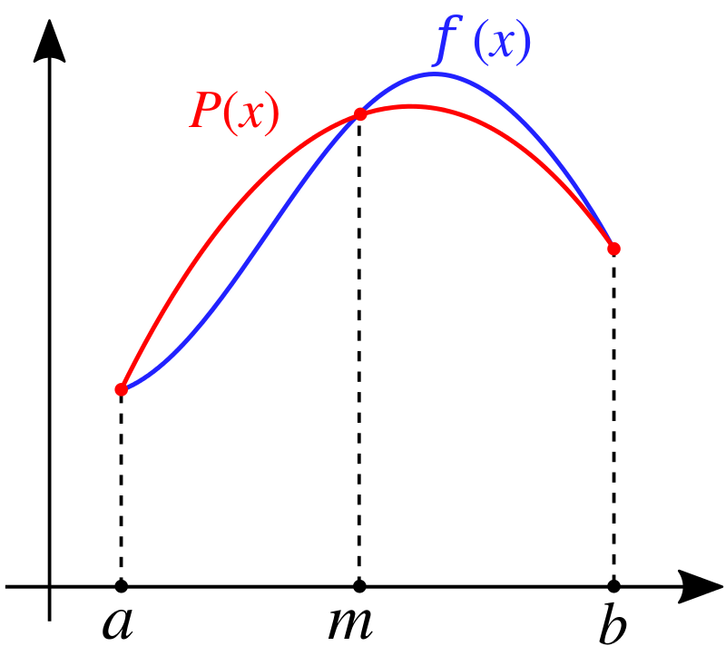

Figure 1

**Simpson’s 1/3 Rule Algorithm**

Here is the pseudo code for the Simpson’s 1/3 rule algorithm:

1. Define the function $f(x)$ to be integrated, the limits of integration $a$ and $b$, and the number of intervals $n$. This needs to be done before the function for Simpson’s Rule.
2. Start a function for Simpson’s 1/3 Rule which takes $f, a, b$ and $n$ as input and returns the integral as the output. In the function:
   1. Set the interval width $h$ to be $(b-a)/n$, where $n$ is the number of intervals.
   2. Initialize a variable sum to 0. This will be used to store the sum of the areas of the intervals.
   3. For each interval $i$ from $1$ to $n$, do the following:
      1. Calculate the $x$ values at the start and end of the interval: $x1 = a + (i-1) * h$ and $x2 = a + i * h$.
      2. Calculate the $y$ values at the start and end of the interval:
 $$y1 = f(x1)$$

 $$y2=f\left(x1+h/2\right)$$

 $$y3 = f(x2)$$

   3. Calculate the area of the parallelogram formed by the three points in the interval:
 $$area = (h/6) * (y1 + 4*y2 + y3)$$

     4. Add the area of the interval to the sum: $sum = sum + area$.
   4. Return the sum as the approximate value of the integral.

**Task 1**

Develop a MATLAB function for the Trapezoidal Rule.

The function should accept the following inputs:

1. Function handle
2. Function Limits
3. Number of divisions

The function should return the function integral as the output.

Write a script that uses the function to calculate the integral of $x⋅\sin\left(x\right)$ between the limits $0$ and $π$.

**Task 2**

Modify the function you wrote so that if accepts vectors of values of $f(x)$ and $x$ points and calculates the integral.

**Code:**

|  |
| --- |
| clear all, clc    f = @ (x) x*sin(x);    %a = 0;  disp('Enter lower bound limit')  a = input("Lower bound limit: ");    %b = pi;  disp('Enter upper bound limit')  b = input("Upper bound limit: ");    %N = 6;  disp('Enter number of intervals')  N = input("Enter intervals: ");    fprintf('\nThe solution using Simpsons 1/3rd Rule is: \n')  integral = simpson_rule (f,a,b,N)    function sum = simpson_rule (f,a,b,N)  sum = 0;    h = (b - a) / N;    for i = 1:N  x1 = a + ((i - 1) * h);  x2 = a + (i * h);    y1 = f(x1);  y2 = f(x1 + h/2);  y3 = f(x2);    area = (h/6) * (y1 + y3 + 4*y2);  sum = sum + area;    fprintf('Y: %.4f, Area: %.2f, Sum: %.4f\n', y1, area, sum)    end  end |

**Command Window Output:**

